Lab 3 (Test): CS527

Release date: 13 August 2026, 2:25pm
Submission date: 13 August 2026, 5:30pm.

Total points 20
Marks rubric:
- Updating compiler to support vector instructions - (3 points)
- Updating processor to support vector instructions - (3 points)
- Array add program - (4 points)
- FIR filter program - (3 points)
- Code quality in overall submission, including lab 1 and lab 2 - (3 points)
- Executable taking program.byte and data.byte as command line input, Makefile/automatic build - (1 points)
- Unseen test cases by instructor - (3 points)
A few more points:
- Viva points are included in each category.
- Optimal use of Vector instructions in Array add and FIR program will also be observed.

Problem Statement:
Simulator a mini-computer system.

Users can write a program in a simple programming language, as specified in the language specification section. A compiler will compile the program, and will generate a byte code. Byte code will be read by a computer system, and will initialise a memory. The processor will read the instruction one by one to execute the program, and will modify the memory. At the end, memory will be written to the computer system in a file.

Finally, compilation and computer system should be invoked by a single main file, and executed as a single executable.

All the changes with respect to Lab 2 is done in blue

Assume all the integer registers in the architecture are of 32 bits. Memory is byte addressable.

In this lab, we introduce vector operations and vector register files. The processor model now has 256 integer registers (x0 to x255) each 32 bit wide and 32 vector registers (v0 to v31) each of 256 bits wide.

Vector operators are: add, sub, multiply, load, store.

Language specification:
Arithmetic operations
Language supports following basic math operations : + - / *
Dest Variable = <Operand 1 variable> <operation> <Operand 2 variable>
Dest Variable = <Operand 1 variable> <operation> <constant value>

Example:
x1 = x2 + 10
x1 = x2 - 20
The maximum value of constant could be 255.

Every addition/subtraction operation updates the following four global flags: Z N C V
Z is 1, if result of operation is 0
N is 1, if MSB of result of operation is 1
C is 1, {For addition: if the unsigned result is strictly less than either of the unsigned inputs}. For subtraction: if operand 1 is bigger than operand 2.
V is 1, {for addition: if both operands sign is same, and sign of result is different than operand’s sign.} {For subtraction: if the operands have different signs, and the result's sign matches the second operand's original sign}

Vector arithmetic:
- Operators allowed: +, - and *
- If right hand side variable name is (v0 to v31) than operation is a vector operation
  - First operand is always vector
  - The second operand can be integer or constant.
  - Operations are performed on 32 bits, assuming the vector has 8 integer elements.
  - Examples are given below:

v3 = v1 + v4; // for(i=0; i < 8; i++) v3_{i} = v1_{i} + v4_{i}
v3 = v1 + 15; // for(i=0; i < 8; i++) v3_{i} = v1_{i} + 15
v3 = v1 * v4; // for(i=0; i < 8; i++) v3_{i} = v1_{i} * v4_{i}
v3 = v1 * x4; // for(i=0; i < 8; i++) v3_{i} = v1_{i} * x4

Memory operations: Read and Write
Read <variable> <address>
Write <variable> <address> //address is a constant

Support of square brackets.
Dest Variable = [Operand 2 variable] //memory read.
[Dest Variable address] = Operand 2 variable //memory write to given address stored in a variable.

Operand could be a variable or a constant.
Example:
x1 = [x2]
[x2] = x1;
x1 = [0]

The maximum value of constant can be 255.

Example of memory operation on vector variables:
v1 = [x2] // for(i=0; i < 8; i++, x2 = x2 +4) v1_{i} = [x2]
v1 = [32] // for(i=0, tmp=32; i < 8; i++, tmp = tmp +4) v1_{i} = [tmp]
[x2] = v1 // for(i=0; i < 8; i++, x2 = x2 +4) [x2] = v1_{i}

Read and Write should be considered legacy instruction. Should not be used in lab 2 onwards - though compiler should still be able to compile them.

Control operations: No control operation supported in today’s lab.

Language support labels. Rules:
- Labels have to start with . character
- They should be the first character of any line (no space or tab should prefix them).
- The label will be an alphanumeric string of characters. No special symbol.
- Line having label will have no other expression
Example:
.label1
.loop

Control operations:
B{Suffix} <label>

Suffix given in table below:

Example:
BEQ .loop
BGE .label1
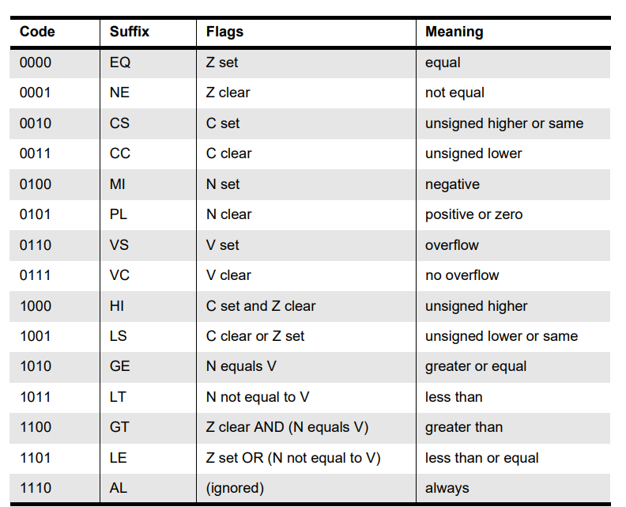
Table is taken from [REF1]
More information about these condition flags [ARM]

Data movement operation:
<Dest Variable> = <constant value>

Variable names: x0 to x255.
Constant value: 0 to 255

Support for comments. Any character following % will be ignored by parser.

Example: Sum of an array. Assume size of Array is stored at address 0, elements stored at 0x4 onwards location. Final result will be stored at address = size * 4 + 4.

x1 = 0 % index
x2 = 0 % sum
x3 = 0 % array address
x4 = [x3] % read the size of array
.loopback
x15 = x1 - x4 % compare
BEQ .exit
x3 = x3 + 4 % increase the address
x6 = [x3] % load the array data
x2 = x2 + x6 % update sum
x1 = x1 + 1 % increment index
BAL .loopback
.exit
[x3] = x2

Example bytecode output of the above program is (written in hex)
F 1 0 0
F 2 0 0
F 3 0 0
5 4 0 3
2 F 1 4
10 0 0 6
9 3 3 4
5 6 0 3
1 2 2 6
9 1 1 1
1E 0 0 FA
6 3 0 2

Byte code specification
Compiler generates a byte code for every operation and finally the byte code is stored in file called “program.byte”.
Format of each line of byte code
<opcode> <dest register> <operand 1> <operand 2>

For branch instructions:
<opcode> <0> <0> <relative offset of jump location>
Relative offset could be positive or negative, such that:
next instruction address = current instruction address + offset.

Operation | Opcode if second operand is a variable | Opcode if second operand is a constant
Integer Add | 0x01 | 0x09
Integer Subtract | 0x02 | 0x0A
Integer Multiply | 0x03 | 0x0B
Divide | 0x04 | 0x0C
Integer Memory read | 0x05 | 0x0C
Integer Memory write | 0x06 | 0x0E
Data movement | 0x07 | 0x0F
Branch | 0x10 + code given in branch table
Vector Add | 0x21 | 0x29
Vector Substract | 0x22 | 0x2A
Vector Multiply | 0x23 | 0x2B
Vector memory read | 0x25 | 0x2C
Vector memory write | 0x26 | 0x2E

In case of memory read, write and data movement operations - operand 1 is 0.

Note that
- Every line has four bytes
- The maximum value for each byte is 255.

Processor specification

Processor
Instruction memory
Size 256 byte
Data memory
Size 4096 byte

Processor has four functions:
reset()
fetch()
decode()
execute()

Following data elements are there in processor:
Int Register[256]
Int PC, opcode, dest, src1, src2
extern char Instruction[256], Data[4096];
Int end_of_simulation = 0

It has a global array of registers of size 256. And a global variable named PC. Also global flags N Z C V

Reset() initializes each element of register array to 0 as well initialize PC to 0
fetch(): reads four bytes from the PC address of instruction memory and stores in opcode, dest, src1, and src2 respectively
decode() : void and empty function at this time
execute(): based on opecode, it performs the operations. Once see 0 opcode, set end_of_simulation = 1

Memory
Memory is coded as a separate ‘c’ file.

Char Instruction[256];
Char Data[4096];

Assumes program.byte and data.byte present in the directory. The memory is byte addressable which means when you read instructions from char array will read the instruction bye-by-byte.

data.byte and program.byte are stored as an array of hex bytes. In each line four bytes in hex format (without prefix 0x) separated by space are stored

For example -1 is represented as
FF FF FF FF

initialize() {
//read the data from “program.byte” and populate Instruction memory
//read the data from “data.byte” and populate data memory.
}

finalize() {
//Write data.byte
}

Main file

main(int argc, char** argv) {

compile();
initialise();
reset();

while(end_of_simulation) {
fetch();
decode();
execute();
}

finalize();

}

It is suggested that the program file is passed as argument to your final executable - using argc and argv.

Directory structure

Following code files should be there:

main.c
compiler.c
compiler.h
processor.c
processor.h
memory.c
memory.h
Makefile

Some tutorials on multi-file compilation:
https://www.codewithc.in/tutorials/multi-file-programs
https://www.w3schools.com/c/c_organize_code.php
You can search more on the internet

Makefile tutorial:
https://makefiletutorial.com/

FAQs

Example user level programs:

- Sum of two arrays A and B of N numbers, the result is stored in another array of N numbers. Though N is given at run time, assume it is always multiple of 8.
  - Four bytes starting from 0x0 stores N
  - Next 4N bytes store the Array A, Next 4N bytes store the array B. Result is stored in the next 4N bytes.
  - Use vector instructions to add these arrays.
- FIR filter response:
  - Input starts at 0x0 of data memory. The first four bytes tell the size of the array, say N. N is always multiple of 8, but less than or equal to 64. Next 32 bytes store 8 weight values. Next 4N bytes are the input array.
  - Output is stored 0x100 onwards..
  - Use Vector instructions to write code for FIR
Pseudo code of FIR filter
for(k=0; k < N-8; k++) {
sum=0;
for(i=0; i < 8; i++) {
sum = sum + input[k+i] * weight[i]
}
output[k] = sum;
}

Data size
- In this assignment, data size is not specified. You can assume each operation is 8 bits, or 32 bits. 32 bit operation size is preferable. Data size is always 32 bit.
Submission Instructions:
- Submit as a single zipped file - containing all your code, and test programs.

